Hands on 7

1.code

**src/Components/ListofPlayers.js**

import React from 'react';

function ListofPlayers() {

const players = [

{ name: 'Virat Kohli', score: 85 },

{ name: 'Rohit Sharma', score: 65 },

{ name: 'Shubman Gill', score: 90 },

{ name: 'KL Rahul', score: 55 },

{ name: 'Rishabh Pant', score: 72 },

{ name: 'Hardik Pandya', score: 88 },

{ name: 'Ravindra Jadeja', score: 60 },

{ name: 'Jasprit Bumrah', score: 40 },

{ name: 'Mohammed Shami', score: 75 },

{ name: 'Bhuvneshwar Kumar', score: 35 },

{ name: 'Yuzvendra Chahal', score: 68 }

];

const lowScorers = players.filter(p => p.score < 70);

return (

<div>

<h2>All Players</h2>

<ul>

{players.map((p, index) => (

<li key={index}>{p.name} - {p.score}</li>

))}

</ul>

<h2>Players with score below 70</h2>

<ul>

{lowScorers.map((p, index) => (

<li key={index}>{p.name} - {p.score}</li>

))}

</ul>

</div>

);

}

export default ListofPlayers;

**src/Components/IndianPlayers.js**

import React from 'react';

function IndianPlayers() {

const teamPlayers = ['Virat Kohli', 'Rohit Sharma', 'Shubman Gill', 'KL Rahul', 'Rishabh Pant', 'Hardik Pandya'];

const [oddPlayers, evenPlayers] = [teamPlayers.filter((_, i) => i % 2 === 0), teamPlayers.filter((_, i) => i % 2 !== 0)];

const T20players = ['Surya Kumar Yadav', 'Ishan Kishan'];

const ranjiPlayers = ['Mayank Agarwal', 'Cheteshwar Pujara'];

const allPlayers = [...T20players, ...ranjiPlayers];

return (

<div>

<h2>Odd Team Players</h2>

<ul>

{oddPlayers.map((p, index) => <li key={index}>{p}</li>)}

</ul>

<h2>Even Team Players</h2>

<ul>

{evenPlayers.map((p, index) => <li key={index}>{p}</li>)}

</ul>

<h2>All Players (Merged)</h2>

<ul>

{allPlayers.map((p, index) => <li key={index}>{p}</li>)}

</ul>

</div>

);

}

export default IndianPlayers;

**src/App.js**

import React from 'react';

import ListofPlayers from './Components/ListofPlayers';

import IndianPlayers from './Components/IndianPlayers';

function App() {

const flag = true; // Change to false to see other component

return (

<div className="App">

{flag ? <ListofPlayers /> : <IndianPlayers />}

</div>

);

}

export default App;

output:

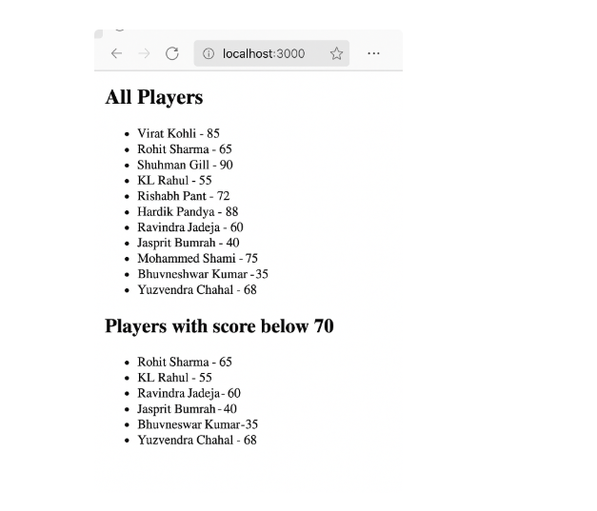

2.code

### src/App.js

import React from 'react';

function App() {

const offices = [

{ name: 'Prestige Towers', rent: 55000, address: 'MG Road, Bangalore', image: 'https://via.placeholder.com/200' },

{ name: 'DLF Cyber City', rent: 75000, address: 'DLF Phase 3, Gurgaon', image: 'https://via.placeholder.com/200' },

{ name: 'Mindspace', rent: 60000, address: 'Hitech City, Hyderabad', image: 'https://via.placeholder.com/200' }

];

return (

<div style={{ padding: '20px', fontFamily: 'Arial' }}>

<h1>Office Space Rental</h1>

{offices.map((office, index) => (

<div key={index} style={{

border: '1px solid black',

borderRadius: '10px',

padding: '10px',

margin: '10px 0'

}}>

<h2>{office.name}</h2>

<img src={office.image} alt={office.name} style={{ width: '200px', height: '150px' }} />

<p style={{ color: office.rent < 60000 ? 'red' : 'green' }}>

Rent: ₹{office.rent}

</p>

<p>Address: {office.address}</p>

</div>

))}

</div>

);

}

export default App;

output:

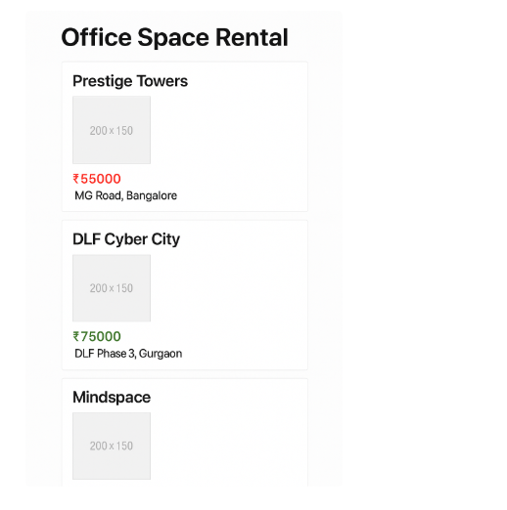

3.code

**src/Components/CurrencyConvertor.js**

import React, { useState } from 'react';

function CurrencyConvertor() {

const [rupees, setRupees] = useState('');

const [euro, setEuro] = useState('');

const handleSubmit = (e) => {

e.preventDefault();

const conversionRate = 0.011; // Example rate

setEuro((rupees * conversionRate).toFixed(2));

};

return (

<div style={{ marginTop: '20px' }}>

<h2>Currency Convertor</h2>

<form onSubmit={handleSubmit}>

<label>Rupees: </label>

<input

type="number"

value={rupees}

onChange={(e) => setRupees(e.target.value)}

/>

<button type="submit">Convert</button>

</form>

{euro && <p>Euro: €{euro}</p>}

</div>

);

}

export default CurrencyConvertor;

**src/App.js**

import React, { Component } from 'react';

import CurrencyConvertor from './Components/CurrencyConvertor';

class App extends Component {

constructor(props) {

super(props);

this.state = { counter: 0 };

}

increment = () => {

this.setState({ counter: this.state.counter + 1 });

};

sayHello = () => {

alert('Hello! Welcome to Event Handling in React');

};

incrementAndGreet = () => {

this.increment();

this.sayHello();

};

decrement = () => {

this.setState({ counter: this.state.counter - 1 });

};

sayWelcome = (msg) => {

alert(msg);

};

handleClick = (e) => {

alert('I was clicked');

};

render() {

return (

<div style={{ padding: '20px', fontFamily: 'Arial' }}>

<h1>Event Handling Example</h1>

<p>Counter: {this.state.counter}</p>

<button onClick={this.incrementAndGreet}>Increment</button>

<button onClick={this.decrement}>Decrement</button>

<br /><br />

<button onClick={() => this.sayWelcome('Welcome!')}>Say Welcome</button>

<br /><br />

<button onClick={this.handleClick}>OnPress</button>

<CurrencyConvertor />

</div>

);

}

}

export default App;

output:

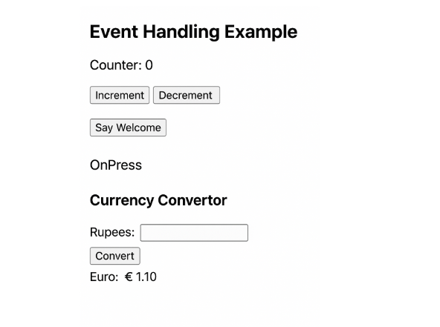

4.code

**src/Components/UserPage.js**

import React from 'react';

function UserPage() {

return (

<div>

<h2>Welcome User</h2>

<p>You can now book tickets for the following flights:</p>

<ul>

<li>Flight 101 - Delhi to Mumbai <button>Book</button></li>

<li>Flight 202 - Bangalore to Chennai <button>Book</button></li>

<li>Flight 303 - Kolkata to Hyderabad <button>Book</button></li>

</ul>

</div>

);

}

export default UserPage;

**src/App.js**

import React, { useState } from 'react';

import GuestPage from './Components/GuestPage';

import UserPage from './Components/UserPage';

function App() {

const [isLoggedIn, setIsLoggedIn] = useState(false);

return (

<div style={{ padding: '20px', fontFamily: 'Arial' }}>

<h1>Ticket Booking App</h1>

{isLoggedIn ? <UserPage /> : <GuestPage />}

<br />

{isLoggedIn ? (

<button onClick={() => setIsLoggedIn(false)}>Logout</button>

) : (

<button onClick={() => setIsLoggedIn(true)}>Login</button>

)}

</div>

);

}

export default App;

output:

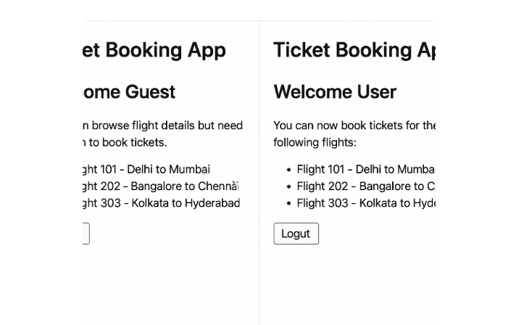

5. code

**src/Components/BookDetails.js**

import React from 'react';

function BookDetails() {

const books = [

{ id: 1, title: 'Learning React', author: 'Alex Banks' },

{ id: 2, title: 'JavaScript: The Good Parts', author: 'Douglas Crockford' }

];

return (

<div>

<h2>Book Details</h2>

<ul>

{books.map(book => (

<li key={book.id}>{book.title} - {book.author}</li>

))}

</ul>

</div>

);

}

export default BookDetails;

**src/Components/BlogDetails.js**

import React from 'react';

function BlogDetails() {

const blogs = [

{ id: 1, title: 'React Hooks Deep Dive' },

{ id: 2, title: 'Understanding Conditional Rendering' }

];

return (

<div>

<h2>Blog Details</h2>

<ul>

{blogs.map(blog => (

<li key={blog.id}>{blog.title}</li>

))}

</ul>

</div>

);

}

export default BlogDetails;

**src/Components/CourseDetails.**

import React from 'react';

function CourseDetails() {

const courses = [

{ id: 1, name: 'ReactJS Bootcamp' },

{ id: 2, name: 'Full Stack Development' }

];

return (

<div>

<h2>Course Details</h2>

<ul>

{courses.map(course => (

<li key={course.id}>{course.name}</li>

))}

</ul>

</div>

);

}

export default CourseDetails;

**src/App.js**

import React, { useState } from 'react';

import BookDetails from './Components/BookDetails';

import BlogDetails from './Components/BlogDetails';

import CourseDetails from './Components/CourseDetails';

function App() {

const [view, setView] = useState('books');

let content;

if (view === 'books') {

content = <BookDetails />;

} else if (view === 'blogs') {

content = <BlogDetails />;

} else if (view === 'courses') {

content = <CourseDetails />;

}

return (

<div style={{ padding: '20px', fontFamily: 'Arial' }}>

<h1>Blogger App</h1>

<button onClick={() => setView('books')}>Show Books</button>

<button onClick={() => setView('blogs')}>Show Blogs</button>

<button onClick={() => setView('courses')}>Show Courses</button>

<hr />

{content}

</div>

);

}

export default App;

output:

